**B. M. S. COLLEGE OF ENGINEERING**

## (Autonomous College under VTU)

**Bull Temple Road, Basavanagudi, Bangalore - 560019**



A report on

***“Oscillators”***

Submitted in partial fulfillment of the requirements for the Activity Plan

**BACHELOR OF ENGINEERING IN**

**Electronics and Communication Engineering**

By

**P Likeeth jain(1BM21EC089)**

**Ashif gheradi(1BM21EC019)**

Under the guidance of

**Dr. Umadevi V Associate Professor**

**Department of Computer Science and Engineering**

### 

### 2021-22

|  |
| --- |
| **B.M.S. COLLEGE OF ENGINEERING**  **(Autonomous College under VTU)**  **Bull Temple Road, Basavanagudi, Bangalore – 560019** |
| **Department of Electronics and Communication Engineering** |

**C E R T I F I C A T E**

This is to certify that the report on “Data Flip-Flop” is a bona-fide work carried out by

**P likeeth jain(1BM21EC089) and Ashif gheradi(1BM21EC019)** as a part of An Activity Plan for the Course **PROBLEM-SOLVING THROUGH PROGRAMMING with course code** **211CC1ESPSP/ 211CC2ESPSP** **Electronics and Communication Engineering** from **Visvesvaraya Technological University, Belgaum** during the year **2021-22**. It is certified that all corrections/suggestions indicated for Internal Assessments have been incorporated in the report deposited in the departmental library.

|  |
| --- |
| **Dr. Umadevi V** |
| **Associate Professor**  **Department of CSE**  **B. M. S. College of Engineering** |

**Acknowledgements**

We would like to thank our guide**, Dr. Umadevi** V for her patience, first and foremost, and guidance throughout this project. With her support and help, this project rose from the ground up.

Lastly, we would like to thank our college, B. M. S. College of Engineering, for providing us with opportunities to develop new and creative project.

**TABLE OF CONTENTS**

|  |  |  |
| --- | --- | --- |
| **SL. NO.** | **TITLE** | **PAGE NO.** |
| 1 | Introduction to oscillators | 2 |
| 2 | Project Flow | 3 |
| 3 | Implementation | 4 |
| 4 | Experimental Analysis and Results | 5 |
| 5 | Conclusion | 6 |
| 6 | GitHub link | 6 |

**1.Introduction**

 An **electronic oscillator** is an electronic circuit that produces a repetitive, oscillating electronic signal, often a sine wave or a square wave. **Oscillators**convert direct current (DC) from a power supply to an alternating current signal. They are widely used in many electronic devices. Common examples of signals generated by oscillators include signals broadcast by radio and television transmitters, clock signals that regulate computers and quartz clocks, and the sounds produced by electronic beepers and video games.

**Types of oscillators**

**a)**RC phase shift oscillator

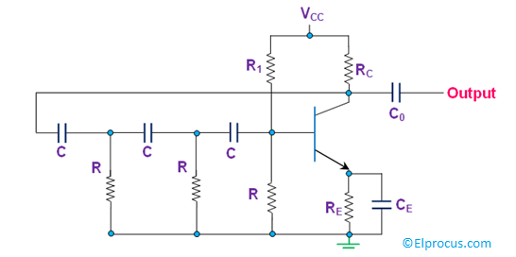

A phase-shift oscillator is a linear electronic oscillator circuit that produces a sine wave output. It consists of an inverting amplifier element such as a transistor or op amp with its output fed back to its input through a phase-shift network consisting of resistors and capacitors in a ladder network.

f = 1 / [ 2*pi*R*C*Sqrt(2*N)]

**b)**Wein bridge oscillator

The **Wien Bridge Oscillator** is so called because the circuit is based on a frequency-selective form of the Wheatstone bridge circuit. The Wien Bridge oscillator is a two-stage RC coupled amplifier circuit that has good stability at its resonant frequency, low distortion and is very easy to tune making it a popular circuit as an audio frequency oscillator but the phase shift of the output signal is considerably different from the previous phase shift **RC Oscillator**.

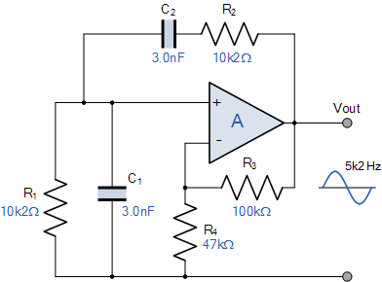

 f = 1/(2*pi*sqrt(R1*R3*C1*C2))

**2. Project Flow**

*Flowchart*

Enter the type of oscillator

Switch(e)

Case b

A

A

Case a

A

A

**NO**

**YES YES**

Frequency=1/(2*pi*sqrt(R1*R2*C1*C2))

Frequency=1/(2*pi*sqrt(6)*R*C)

Print frequency

Default

**3. Implementation**

***The code is given as follows:***

**#include<stdio.h>**

**#include<conio.h>**

**#include<math.h>**

**#define pi 3.14**

**Void main()**

**{**

**char a,b,c,e;**

**float f;**

**clrscr();**

**printf("select the type of oscillator:\n a-RC phase shift oscilltor\n b-wein bridge oscillator\n");**

**printf("enter the selection:\n");**

**scanf("%c",&e);**

**switch(e)**

**{**

**case'a':**

**{**

**float R,C;**

**printf("the value of R and C:\n");**

**scanf("%f%f",&R,&C);**

**f=1/(2*pi*sqrt(6)*R*C);**

**printf("the frequency of oscillation of the phase shift oscillator=%f",f);**

**}**

**break;**

**case'b':**

**{**

**float R1,R2,C1,C2;**

**printf("enter the value of R1,C1,R2,C2:\n");**

**scanf("%f%f%f%f",&R1,&C1,&R2,&C2);**

**if(R1==R2&&C1==C2)**

**{**

**printf("it is a balanced wein bridgec oscillator\n");**

**}**

**f=1/(2*pi*sqrt(R1*C1*R2*C2));**

**printf("the frequency of oscillation of the wein bridge oscillator=%f",f);**

**}**

**break;**

**default:**

**printf("wrong selection!!");**

**}**

**}**

**4. Experimental Analysis and Results**

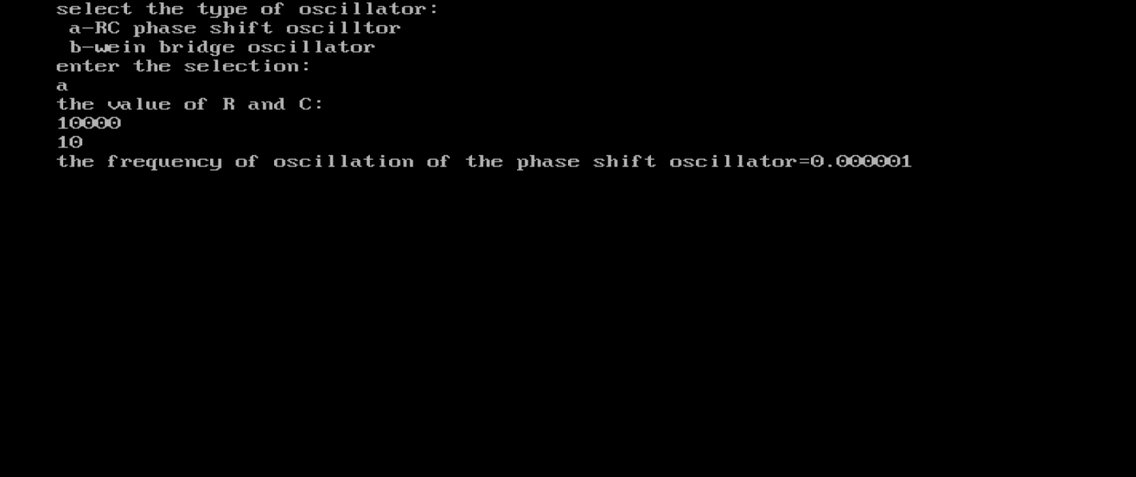

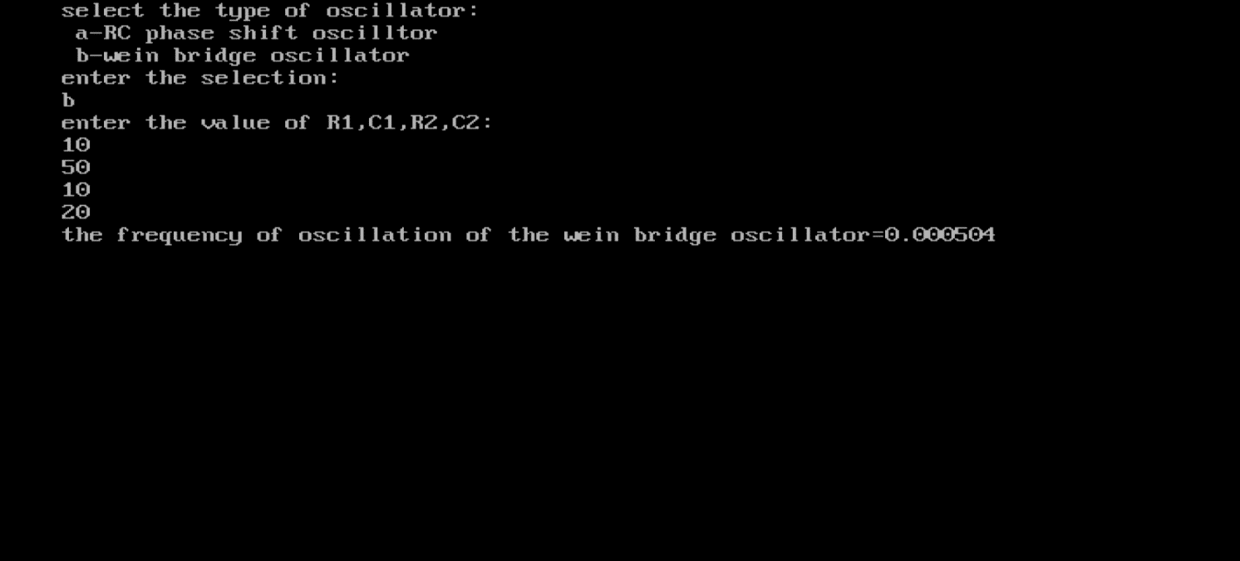

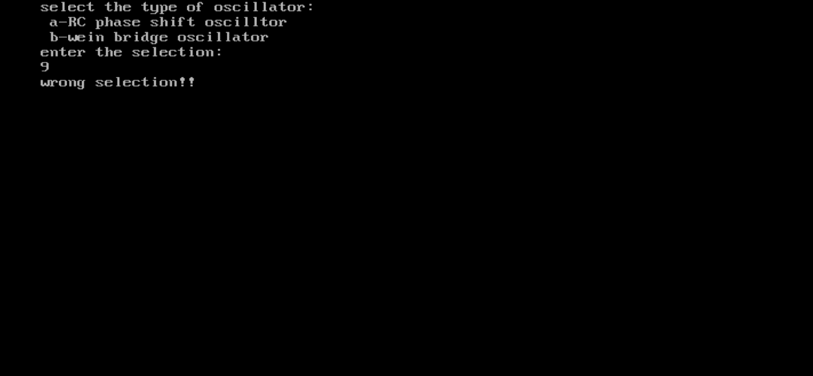

**Conclusion**

Through the above code implementation and its results, we can choose the type of oscillators and then using frequency formula **f=1/(2*pi*sqrt(R1*C1*R2*C2)) and f=1/(2*pi*sqrt(6)*R*C)** by the given values of R and C. we can find frequency of the selected type of oscillator.

**GitHub link**